**Sebastian Oakes – Computational Neuroscience - Assignment 3**

*All figures plotted using GnuPlot.*

Ex. 1)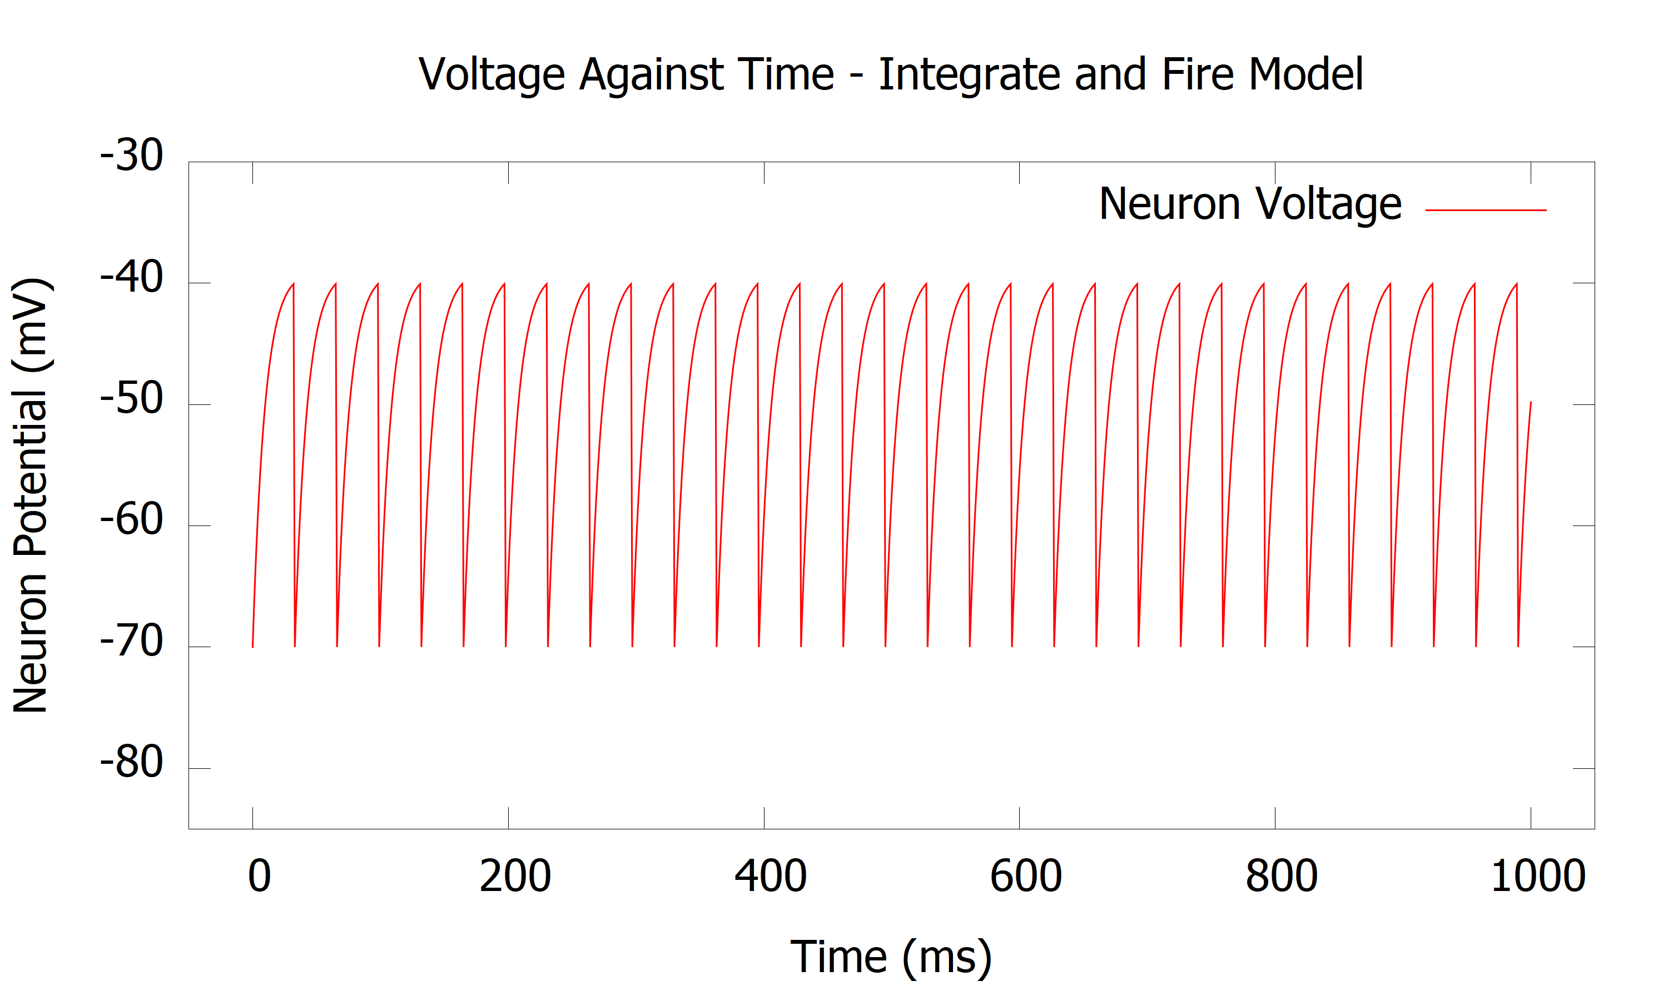

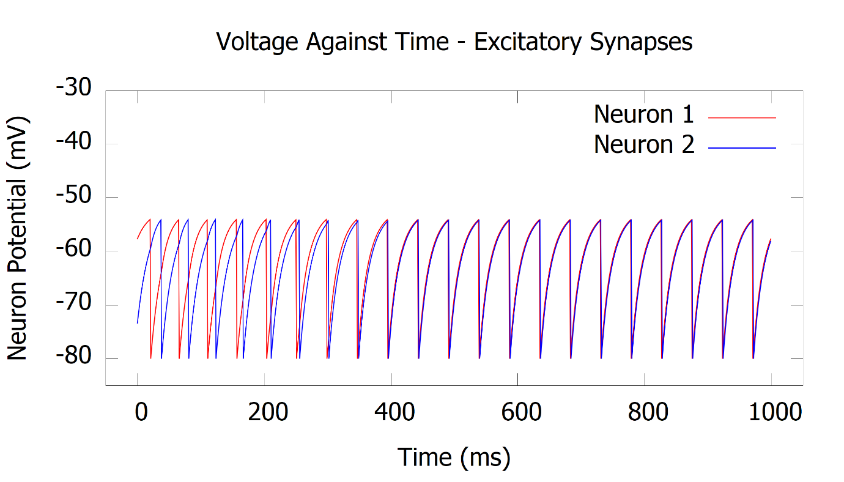Figure 1 - Plot displaying the results of a simulated integrate and fire model using the parameters specified. The data was created using Euler’s method for numerically solving differential equations, with a timestep of dT = 1ms.

Figure 2 – Exercise 2 - Plot displaying the voltage results for the two modelled neurons over the 1 second period, connected using excitatory synapses. Of note is the gradual trend towards the neurons firing synchronously. Once the firing rates are matched, the model becomes stable. Both neuron and synapses modelled using Euler’s method.

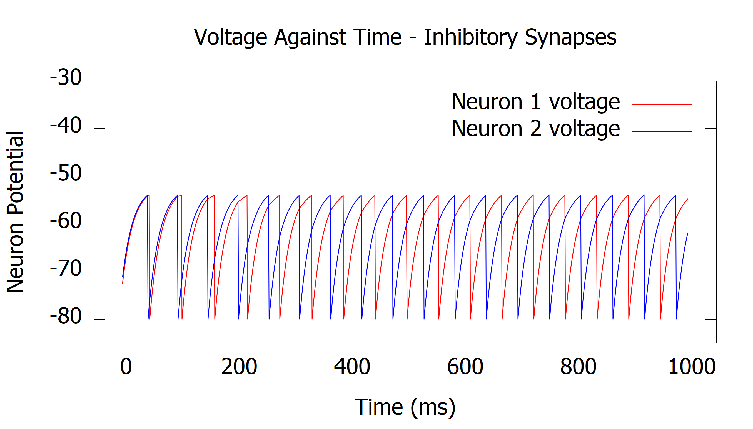Figure 3 – Exercise 2 -Plot displaying the voltage results for the two modelled neurons over the 1 second period, connected using inhibitory synapses. Once again a trend is obvious, this time towards asynchronous neuron firing, at which point the model reaches an equilibrium point.

Ex.3)

Since, with constant current:

$$V\left(t\right)=E_{L}+R_{m}I_{e}+[V\left(0\right)- E_{L}-R_{m}I_{e}]e^{\frac{-t}{τ_{m}}}$$

It can be seen that as ‘t’ tends to infinity, the exponential term tends towards zero. With this is mind, the minimum value for current can be found by replacing V(t) with VT, the threshold value:

$$I_{e}= \frac{V_{T}{-E}_{L}}{R_{m}}$$

Using the same parameters as for exercise 1, this gives a value of Ie = 3 nA.

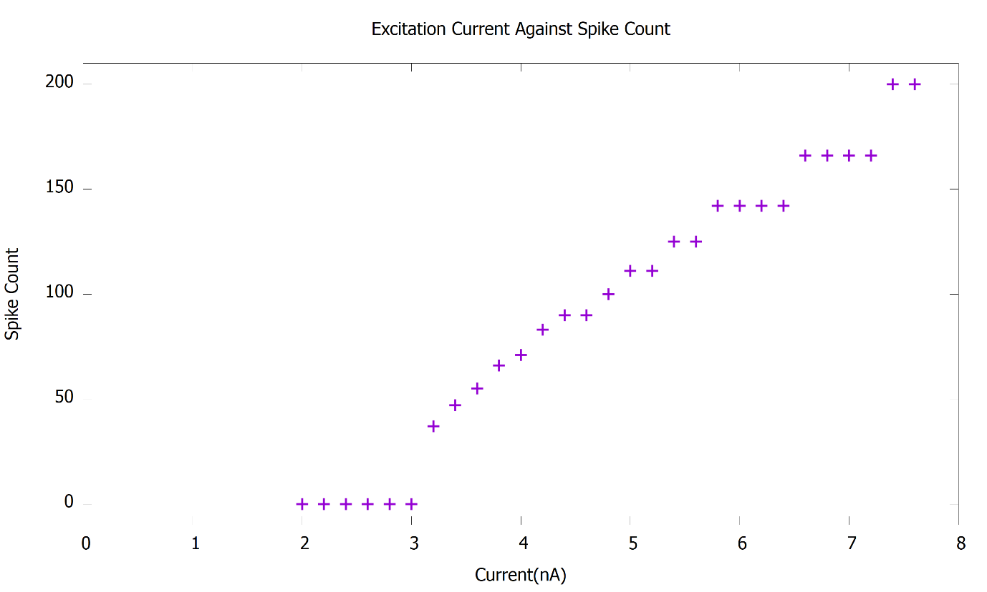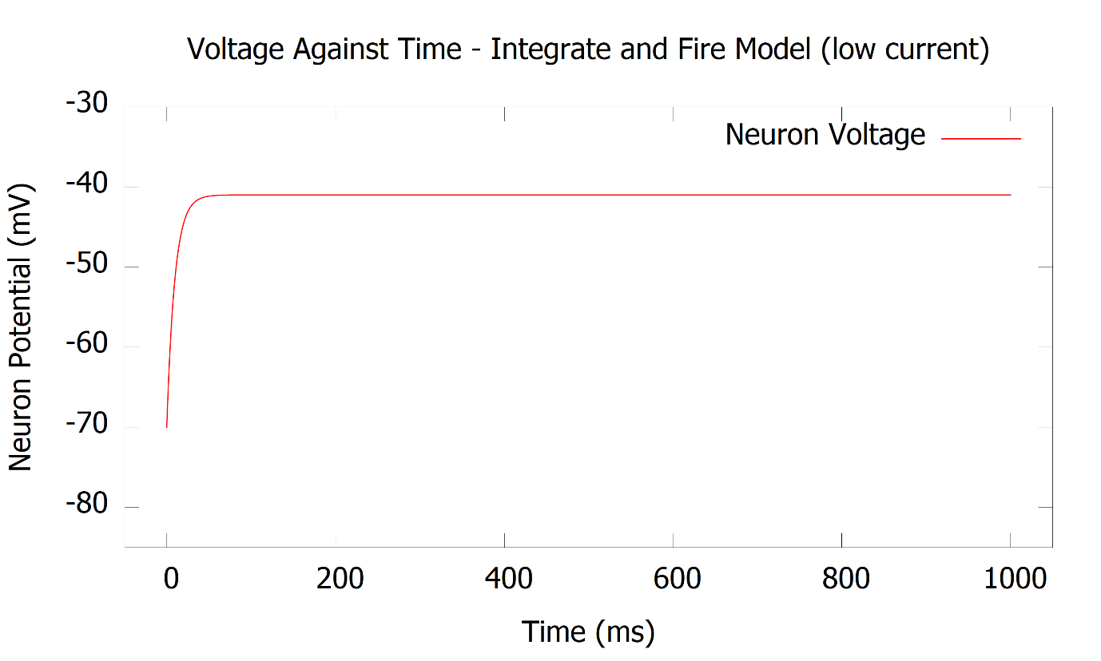

Figure 5 - Exercise 3 - Plot displaying the relation spike count against current. Each point represents the spike count after a full one second period.

Figure 4 - Exercise 3 - Plot displaying the neuron voltage against time for the one second period, when using an input current of 2.9 nA. It is clearly seen that the voltage fails to reach the threshold value to cause an action potential.